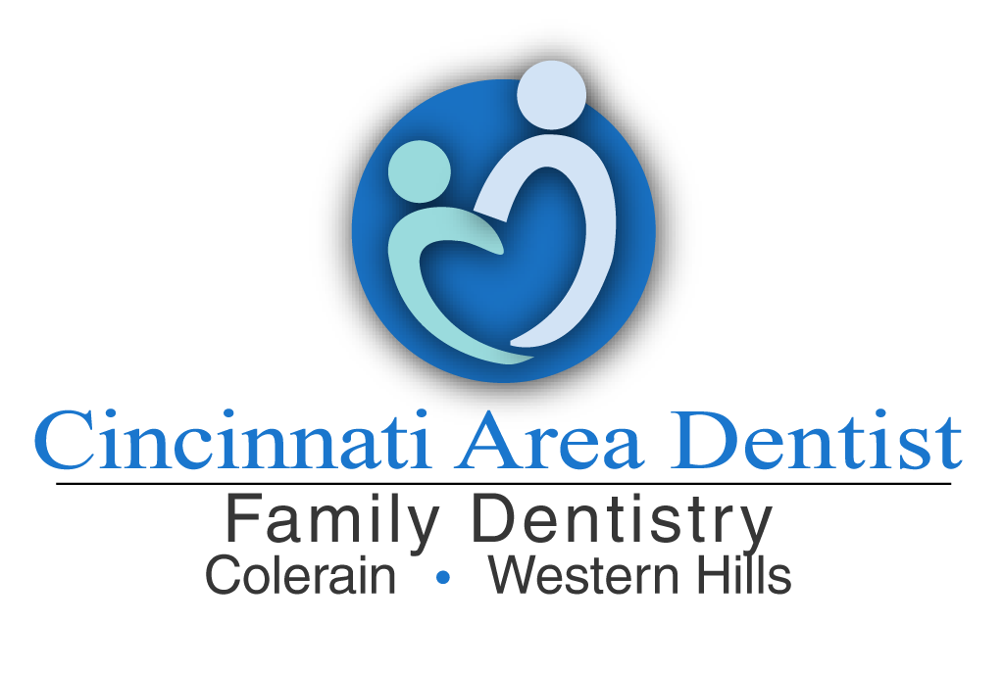
Dr. Khetarpal chooses the specialists she works with based on their quality of work and compassionate care. If you choose to go to someone that is not on this list there will be no guarantee that Dr. Khetarpal will continue with your planned treatment.

If you have received a referral to a specialist and you find they are out of network please use the list below for alternative doctors. Please call our office at 513-923-1215 so we can transfer your radiographs and chart notes to the specialist office.

Please note that due to your insurance there may not be any specialists that are in-network.

Endodontist (Root canal specialist):

- Dr. Timothy Kreimer http://www.timkreimerendo.com/ 513-385-9888
- Dr. Eric Brown https://ericbrownendo.com/index.html 513-241-0018
- Drs. Vaishali Agarwala and Thomas Yonchak 513-829-1935
- Dr. Robert S. Schneider http://www.schneiderendo.com/ 513-661-7668
- Dr. Sheenu Goel https://empiredentalspecialty.com/ 513-682-2345
- Dr. Adam Hadsell https://cincyendo.com/ 513-786-0260
- Dr. Harish Malyala https://www.rivervalleyendodontics.com/ 859-780-2550
- Dr. Yoder https://www.crestviewendo.com/ (859) 331-2800

Orthodontics (braces):
- Dr. Fernando Martinez http://www.martinezortho.com/ 513-598-9800
- Dr. Donald Murdock https://www.murdockorthodontics.com/ 513-662-2100
- Dr. Kent Morris https://www.kentmorrisorthodontics.com/513-683-3900
- Dr. Nelson Diers http://www.diersorthodontics.com/ 513-829-4400
- Dr. Darcie Bradley http:// https://drbradleyortho.com/ 513-385-2161
- Dr. Spencer Boley https://boleybraces.com/ 513-347-9222
- Dr. Monica Newby http://www.newbyorthodontics.com/ 513-531-7566
- Dr. Stephen Haverkos https://haverkosreddyorthodontics.com/ 513-481-8000

Oral Surgeons (extractions/implants):
- Drs. Harper and Fisher https://www.cincinnatioms.com/ 513-451-7300
- Drs. Cassidey, Pieper, Shibler, Spencer https://www.cincinnatioralsurgery.com/ 513-385-7170
- Drs. Nall, McDaniel and Conley https://www.aomsohio.com/ 513-829-8080
- University of Cincinnati 513-584-7910
- Drs. Deshmukh and Emami https://www.drgarypies.com/ 513-923-1500
- Drs. Thatcher and Boudreau https://www.cincinnati-oralsurgeons.com/
513-521-0110
- Dr. Murnan, Seghi, Lucas https://www.cincinnatioralsurgeons.com 513-661-7410

Periodontist (periodontal disease/grafting/implants):
- Dr. Mary Ann Hanlon https://www.cinciperio.com/ 513-662-4867
- Dr. Michael Toms http://www.yourhealthygums.com/ 513-922-7300
- Dr. Ray Bonomo https://www.bonomoperiodontics.net/ 513-671-0222
- Dr. Matt Parker https://www.parkerperio.com/ 513-474-4486
- Dr. Vlad Shapiro http://healmygums.com/ 513-984-4867
- Dr. Larry Martin http://www.martinperio.com/ 513-829-8999
- Dr. Neal Lemmerman http://www.lemmermanperiodontics.com/ 513-581-9292
- Dr. Stacey Blume https://www.topgums.net/ 513-871-8488

Pediatric:
- Smiles 1st Dental https://smiles1stdental.com/513-540-4785
- Dr. Marie Callen https://www.mariecallen.com/513-376-8200
- Dr. Dennis Lambert https://www.cincykidsteeth.com/ 513-574-8100
- Dr. McNamara http://thepediatricdentist.com/ 513-662-5203
- Dr. Katie Blomer https://hydeparkpediatricdentistry.com/ 513-979-6998
- Dr. Petr Vaughan https://www.westsidepediatricdental.com/ 513-450-3637
- Dr. Kennedy + Dr. Skeleton https://www.chewchewjunction.com/ 513-858-6575
- Dr. Laura Doss https://www.villagepedsdentistry.com/ 513-844-0046

Prosthodontist (dentures, partials, implant restorations)
- Dr. David Carrier http://www.dcarrierdds.com/
- Dr. Manish Chopra http://www.chopras.com/
- Dr. Robert Fulkner https://www.faulknerdentistry.com/
- Dr. Mi Young Kim https://med.uc.edu/depart/surgery/directory/faculty-profile/Index/Pubs/kim3my

Oral Facial Pain:
- Dr. Gary Robins https://www.uchealth.com/physician/gary-robins/

Facial physical therapy:
- https://blakeandassociatespt.com/

